TC-CSC-014
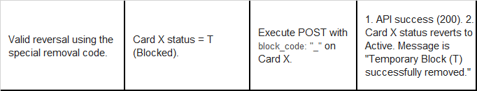
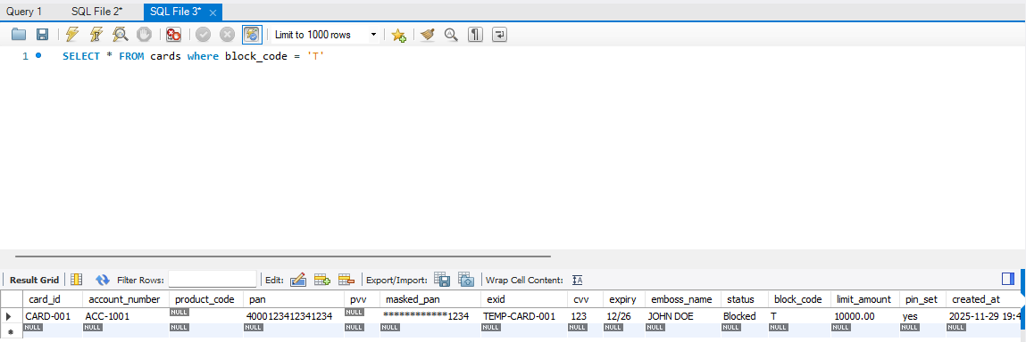
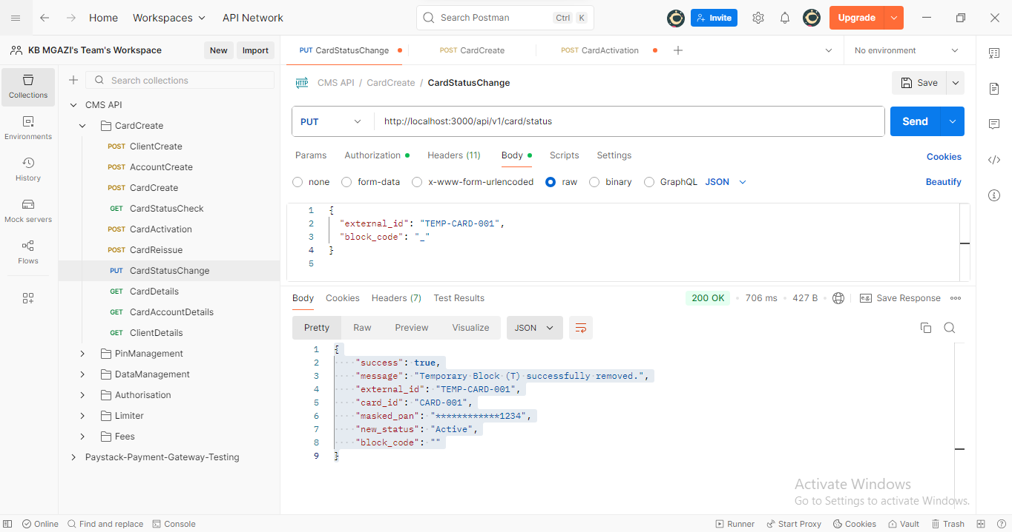
Request:
{
"external_id": "TEMP-CARD-001",
"block_code": "_"
}

Response:
{
"success": true,
"message": "Temporary Block (T) successfully removed.",
"external_id": "TEMP-CARD-001",
"card_id": "CARD-001",
"masked_pan": "************1234",
"new_status": "Active",
"block_code": ""
}

